Orange = template suggestions

Green = additional information that we would like from SEA Lab

**Project Title: Desalination Example**

Note: proposals should be 1-2 pages, not including Appendices.

**PI:** Maha Haji, Assistant Professor, Mechanical Engineering, Cornell University

**Project personnel:** Nate DeGoede (Ph.D. student)

**Abstract**

The impending surge in global water demand, projected to increase by 20-50% in the next two decades, necessitates innovative solutions to ensure sustainable water supply. Desalination technology, pivotal in addressing this challenge, requires advancements to enhance its cost-effectiveness and efficiency. This proposal outlines a collaboration between MathWorks and the [Symbiotic Engineering and Analysis (SEA) Lab](https://sea.mae.cornell.edu/) at Cornell University, led by PI Maha Haji, to develop Simscape Fluids-based tools for accelerating desalination technology development.

Despite customer demand, current Simscape capabilities for multispecies liquid models are limited. With a project duration of three months and a budget of $12,450, this collaboration aims to expand Simscape's capabilities to address current limitations, aligning with MathWorks's long-term strategy to offer robust modeling tools for various applications.

Key deliverables include a publicly available desalination example, released under a BSD license, that will feature an expanded Simscape custom multispecies liquid domain, desalination-application-focused blocks like a mixing chamber and membrane, and an example model with comprehensive documentation. Additionally, an academic publication will document engineering design insights derived from the model. This project also sets the stage for future collaborations and experimental validations.

**Introduction**

Significance of the project and prior work.

In the coming 10-20 years, the demand for clean water by industry, consumption, and agriculture [is expected to grow between 20 and 50 percent.](https://www.marketresearchfuture.com/reports/water-desalination-market-11785" \l ":~:text=Global Water Desalination Market Overview&text=The Water Desalination market is,period (2023 - 2030).) Water desalination technology will likely play a large role in providing this water. Development of this technology can be accelerated by creating models that allow engineers and scientists to study means of making the desalination process more cost effective and efficient. Simscape does not currently provide tools for modeling desalination processes. MathWorks would like to work with the SEA Lab to develop Simscape Fluids-based tools for studying this problem.

**Expected results**

Please include **milestones with timeline estimates** for key outcomes, such as release of datasets, code releases, publications, workshops, etc.

Please note: It is our desire that artefacts are released publicly under a permissive license such as BSD or MIT.

The project will result in the following deliverables:

1. GitHub/MATLAB Central File Exchange post of a desalination example in Simscape, published under a BSD license. Three key aspects of the post are:
   1. **New Fluid Domain** – A Simscape domain based on the shipping Thermal Liquid (TL) domain that tracks species in the liquid network will be extended to accommodate the requirements of the separation process.
   2. **Supporting Simscape Blocks** – Key components like a mixing chamber (for blending solutions) and a membrane (for separation processes).
   3. **Example Project & Documentation** – A reverse osmosis desalination model with detailed documentation to facilitate future adoption and expansion.
2. An academic publication containing engineering design insights found using a desalination model.

Additionally, MathWorks and Cornell look forward to gaining the following benefits through the collaboration:

* + 1. Explore what model features are required for a generic multispecies liquid domain that is useful for many other applications, such as flow batteries, separators, medical (in-silico), food, and waste processing.
    2. Open the path to future collaborations where the lab can do experiments to validate models or develop prototypes that demonstrate the value of Simscape as part of complete engineering design workflows.

**Support required**

Please provide details on the funding required to support the project.

$12,441 to support 1 Ph.D. student for 3 months with a standard gift letter. This cost includes Cornell’s 10% overhead for gifts. The funding begins on May 27, 2025.

MathWorks will assist the SEA Lab in the form of technical advice and coaching during weekly meetings. MathWorks will also provide existing code examples and a preliminary domain definition.

**Appendix A – CV of PI**

**Appendix B – Previously Funded Project(s) Summary**

If you have received funding from MathWorks previously, please provide details on the project and a short summary of any notable results, papers or other outcomes.

@Nate, can you add a short description here that relates to any of your projects that you and I chatted about (even though there wasn’t any MathWorks funding)? This adds more evidence suggesting that the proposed collaboration will be successful. I believe we’ve discussed converting WEC-Sim to isothermal liquid, super critical CO2 modeling, workarounds to model actuators and multi-way directional valves in two-phase, creating a custom two-phase fluid pipe to model varying dynamic viscosity and other fluid effects due to varying hydrostatic pressure with water depth.

Our team in the SEA Lab at Cornell University as collaborated with Dr. Jocelyn Kluger on multiple projects in an unfunded capacity. Her support has enabled us to advance by contributing insights that have enhanced our simulations and methodology, strengthening the overall impact of our projects.

**Wave Driven Desalination System Hydraulics Modeling:**On this project, we collaborated with Dr. Kluger to convert elements of an existing model from the hydraulics toolbox to the isothermal liquid toolbox. While the automatic converter did not work perfectly, Dr. Kluger assisted in debugging the results. This model later served as the foundation for a multidisciplinary design optimization study led by Nate (<https://github.com/symbiotic-engineering/mdo_wd2>) and detailed further in Appendix C below.

**Wave Powered Carbon Sequestration Fluid Dynamics Modeling:** On this project, we collaborated with Dr. Kluger to develop a model of a wave powered carbon sequestration system model using Simulink and Simscape (<https://github.com/symbiotic-engineering/CASHEW>). Dr. Kluger’s expertise was instrumental in multiple aspects of this work. She advised the use of the two-phase fluid domain, enabling us to accurately model both liquid and supercritical CO2. Additionally, Dr. Kluger helped us navigate domain limitations, particularly by helping us develop the proper actuators and directional valves for this less developed modeling space. Lastly, Dr. Kluger was essential in the creation of a custom a two-phase fluid pipe Simscape block, which accounted for dynamic viscosity and hydrostatic pressure variations in a tall vertical pipe. As detailed below in Appendix C, with Dr. Kluger’s support, our work has resulted in a conference presentation (N. DeGoede, R. McCabe, O. Vitale, C. Pokigo, E. Srivastava, M. Edwards, and M. N. Haji “Offshore Carbon Sequestration Using Direct Mechanical Wave Energy,” *Third Annual University Marine Energy Research Community Conference,* Duluth, MN, August 7-9, 2024) and was selected by the DOE Power at Sea Prize (<https://www.herox.com/PowerAtSea>) as a CONCEPT phase winner. Our team is currently expanding on this work for a DESIGN phase submission in June 2025.

**Appendix C – Prior contributions in the MathWorks ecosystem (optional)**

If you have published any papers, code, datasets, etc using or mentioning MathWorks products, made contributions to MATLAB Central file exchange, GitHub, etc, or participated in MathWorks organized events, please provide details of that here.

@Nate and Maha, can you add any short descriptions of other research you completed or courses you taught that resulted in publications or github repositories etc. that leveraged MathWorks products? The decision-makers like to see evidence that what we work on for this project will reach a wide audience, and you’ll require less ramp-up time using the MathWorks tools.

**SEA Lab Research:** In the SEA Lab, PI Maha Haji’s trainees utilize MathWorks tools for a variety of research projects. Some notable examples have included the following:

* Multidisciplinary Optimization to Reduce Cost and Power Variation of a Wave Energy Converter
  + This study presents the first application of multidisciplinary design optimization (MDO) to enhance the cost efficiency and power stability of the Reference Model 3 (RM3) wave energy converter (WEC) developed by Sandia and NREL. MDO is a computational approach that integrates optimization techniques across multiple interconnected disciplines to achieve the best overall system performance by simultaneously considering design trade-offs and constraints. ***Our project leverages MATLAB for the integrated dynamics and structural modeling and utilized built-in MATLAB functions for sequential quadratic programming to minimize both the levelized cost of energy (LCOE) and the coefficient of variation in power output.***
  + The optimized design achieves a seven-fold cost reduction ($0.08/kWh) and a 23% lower power variation compared to the baseline model. Sensitivity analysis reveals that LCOE is primarily influenced by economic and site factors, while power variation remains largely insensitive to design changes. A Pareto trade-off between cost and power variation highlights three optimal WEC designs (Figure 1): one minimizing cost for utility-scale applications, another minimizing power fluctuation for offshore autonomous systems, and a balanced design for intermediate cases. This research provides key insights for tailoring WEC designs based on specific operational needs, offering a roadmap for more viable and stable wave energy solutions.

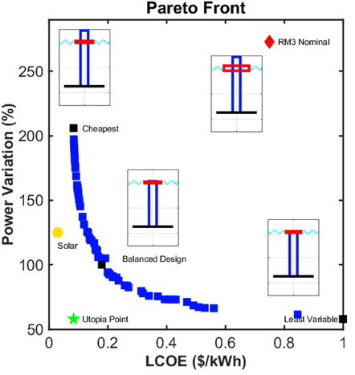

Figure 1: Pareto front capturing the trade-off between LCOE and power variation.

* + This study has resulted in a conference publication (R. McCabe, O. Murphy, and M. N. Haji, “Multidisciplinary Optimization to Reduce Cost and Power Variation of a Wave Energy Converter,” ASME IDETC-CIE, St. Louis, MO, August 14-17, 2022.) and an upcoming journal publication (R. McCabe and M. N. Haji, “Leveraging Multidisciplinary Design Optimization and Semi-Analytical Modeling to Advance Wave Energy Converter Viability,” *in prep. for Renewable Energy*).
  + All code is available on our lab’s github: <https://github.com/symbiotic-engineering/MDOcean>
* Integrated Pumped Hydro Reverse Osmosis System Optimization
  + In this project, our team presents an Integrated Pumped Hydro Reverse Osmosis System (IPHROS) that combines pumped storage hydropower (PSH) and reverse osmosis (RO) desalination to enhance energy storage efficiency and freshwater production. Our approach leverages mountaintop reservoirs to provide natural pressurization for RO, reducing costs and brine disposal challenges while improving grid stability. ***We utilized MATLAB to develop a new RO model incorporating surrogate modeling and MATLAB’s built-in optimization toolbox to conduct multi-objective multidisciplinary design optimization to maximize energy recovery, freshwater output, and RO system efficiency.***
  + Results indicate a 16% reduction in breakeven time compared to separate PSH and RO implementations, with the optimized design delivering 79.5 million kWh of energy and 5.79 million cubic meters of freshwater.
  + This study has resulted in a journal publication (M. Haefner and M. N. Haji, “Integrated Pumped Hydro Reverse Osmosis System Optimization Featuring Surrogate Model Development in Reverse Osmosis Modeling,” *Applied Energy,* 352, 121812, 2023). It was also featured on the Cornell Chronicle (<https://news.cornell.edu/stories/2023/12/seaworthy-solution-yields-green-energy-fresh-water>) and IEEE Spectrum (<https://spectrum.ieee.org/pumped-storage-hydropower>).
  + All code is available on our lab’s github: <https://github.com/symbiotic-engineering/IPHROS_Applied_Energy_2022>
* CArbon Sequestration Harnessing Energy from Waves (CASHEW)
  + In this project, (detailed briefly in Appendix B), our team proposed a novel approach to marine carbon dioxide removal (mCDR) by utilizing wave energy converters (WECs) to directly pump liquid CO₂ into the deep ocean for long-term sequestration. Our team hypothesized that the direct-drive nature of WECs eliminates the need for electrical conversion, improving efficiency over wind- or solar-powered alternatives***. For this, we developed a Simscape model to evaluate the proposed system, examining examines key system parameters like injection depth, pipe diameter, and CO₂ flow rate.***
  + Our results indicate that a single WEC can sequester 0.32 Mt of CO₂ per year, and a global fleet of 31 arrays of 100 WECs could remove 1 Gt/year, a scale significant for climate impact. Our economic assessments (Figure 2) suggest that despite a higher levelized cost of energy (LCOE), wave energy’s direct-drive efficiency lowers the levelized cost of carbon sequestration (LCOC) compared to other renewable-powered approaches. Future work includes refining system specifications, advancing modeling, and pursuing partnerships for prototyping and deployment, with a focus on abandoned offshore oil rigs (such as with partnerships with the Gulf Offshore Research Institute) as potential sites.

Figure 2: Economic comparison for the levelized cost of carbon figure of merit for solar, wind, and wave energy sources. Lower figure of merit (blue) is more viable.

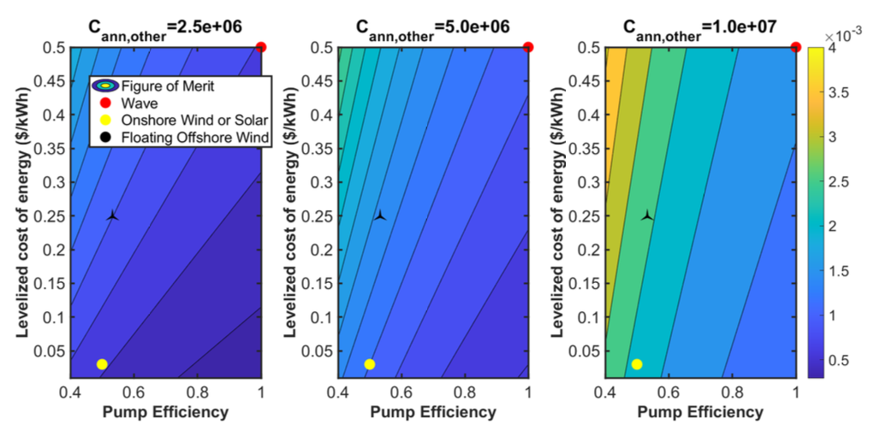

* + This study has resulted in a conference presentation (N. DeGoede, R. McCabe, O. Vitale, C. Pokigo, E. Srivastava, M. Edwards, and M. N. Haji “Offshore Carbon Sequestration Using Direct Mechanical Wave Energy,” *Third Annual University Marine Energy Research Community Conference,* Duluth, MN, August 7-9, 2024) and was selected by the DOE Power at Sea Prize (<https://www.herox.com/PowerAtSea>) as a CONCEPT phase winner. Our team is currently expanding on this work for a DESIGN phase submission in June 2025.
  + All code is available on our lab’s github: <https://github.com/symbiotic-engineering/CASHEW>
* Wave-Driven Desalination
  + This study (detailed briefly in Appendix B), explores the potential of Wave Energy Converters (WECs) to power sustainable potable water systems, addressing global water scarcity while advancing wave energy technology. It highlights Wave Driven Desalination Systems (WDDS), which directly convert wave motion into pressurized seawater for reverse osmosis (RO) desalination, offering higher efficiency than traditional electricity-powered desalination, giving WECs a much needed edge over other more developed renewables in this application.
  + Preliminary results suggest that while keeping feedflow fluctuations to a minimum reduces required RO capacity, it’s economically advantageous to allow for more pressure fluctuation. This is because of the high cost for the hydraulic accumulators required to completely smooth the large pressure fluctuations, and the reduction in system stiffness creates a hydraulic circuit that has better impedance matching with the WEC and wave spectrum. This goes against traditional WDDS design strategies where the coupling between WEC and RO dynamics are not fully understood.
  + This study will be submitted to the upcoming *University Marine Energy Research Community Conference,* Corvallis, OR, August 12-14, 2025 (N. DeGoede, and M. N. Haji, “Multidisciplinary Design Optimization of a Wave Driven Desalination System,” *in prep*.) and will be the subject of a longer journal paper to be submitted this summer.
  + All code is available on our lab’s github: <https://github.com/symbiotic-engineering/mdo_wd2>
* The power balancing benefits of wave energy converters in offshore wind-wave farms with energy storage
  + In this project, we examined the role of wave energy converters (WECs) in improving power stability and cost efficiency in offshore wind-wave farms with energy storage. By integrating WECs with floating wind turbines (FWTs) and compressed air energy storage (CAES), we evaluated how co-locating wind and wave power impacts power predictability, supply smoothness, energy curtailment, and overall grid efficiency. ***We leveraged MATLAB for the modeling and optimization in this project, including the modeling of the standalone and combined system dynamics to determine energy production, the sizing of the CAES energy storage system, as well as the economic analysis. We leveraged a parameter sweep and optimization of energy storage scheduling, leveraging MATLAB’s built-in optimization toolbox.***
  + Our results show that a 50%-50% wind-wave farm reduces power variability by 16%, decreases curtailed energy by 6%, and improves efficiency by 2% compared to a purely wind-based system.
  + This study has resulted in a journal publication (J. M. Kluger, M. N. Haji (co-first author), and A. H. Slocum, “The power balancing benefits of wave energy converters in offshore wind-wave farms with energy storage,” *Applied Energy,* 331, 120389, 2023).
  + All code is available on our lab’s github: <https://github.com/symbiotic-engineering/FWT_WEC_Applied_Energy_2022>
* Hybrid Wind-Wave Energy Systems
  + In this work, we are exploring the integration of offshore wind and wave energy in hybrid systems to enhance energy production, reduce costs, and improve infrastructure efficiency. Using numerical simulations, we examine a floating offshore wind turbine (FWT) coupled with a heaving point absorber wave energy converter (WEC), evaluating key factors such as platform stability, dynamic interactions, mooring loads, and power generation. ***We leveraged multiple MathWorks products (Figure 3) for the modeling and simulation in this project, specifically using NEMOH (MATLAB), WEC-Sim (MATLAB/Simulink), MOST (MATLAB), and MoorDyn (MATLAB).*** 
    - *NEMOH, an open-source boundary element method (BEM) solver based in MATLAB calculated the hydrodynamic coefficients and wave interactions for all floating bodies.*
    - *WEC-Sim, an open-source MATLAB/Simulink tool developed by Sandia National Laboratories and NREL, modeled the hydrodynamic performance of the WEC.*
    - *MOST (MATLAB for Offshore Floating Wind Turbine Simulation Tool) handled the aerodynamics, floating platform hydrodynamics, and power generation of the offshore wind turbine.*
    - *MoorDyn, a lumped-mass mooring system model from NREL, simulated mooring dynamics and cable tensions.*

Figure 3: Coupling framework leveraging MathWorks tools for hybrid system modeling.

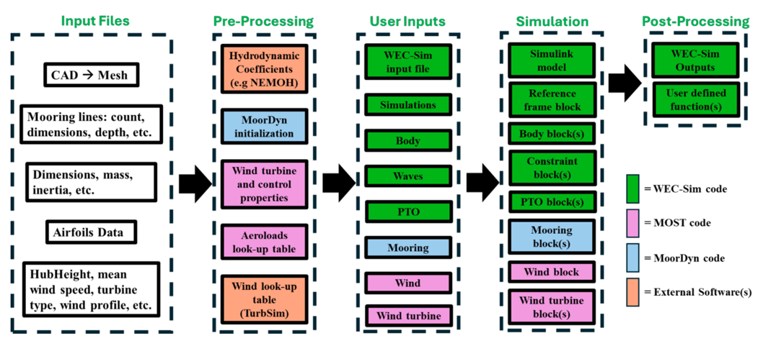

* + Our analysis demonstrates that incorporating a reaction plate enhances system stability and energy absorption. Findings indicate a 38% reduction in the levelized cost of energy for the WEC without impacting OWT costs, highlighting the economic viability of hybrid offshore renewable systems. Further assessments will refine hydrodynamic modeling, mooring system optimization, and cost-benefit analysis to support large-scale deployment.
  + This study has resulted in an accepted conference paper (A. Ahmed, and M. N. Haji, “Integrated Offshore Wind and Wave Energy: Dynamic Interactions and Economic Potential of Hybrid Systems” accepted to *ASME OMAE 2025*, Vancouver, Canada, June 22-27, 2025) and is the subject of a longer journal paper in preparation.
  + All code is available on our lab’s github:

**Tool Development:** Nate DeGoede and Prof. Maha Haji have also contributed to the MathWorks ecosystem in smaller ways through tool development. Through these contributions, they have helped improve the workflow for using MathWorks products in the marine energy research community.

* Nate has contributed to WEC-Sim (<https://github.com/WEC-Sim/WEC-Sim>), the standard MATLAB/Simulink based tool for wave energy converter dynamics simulation used by both academia and industry (his modifications are currently under review as part of a pull request).
* Nate has also developed a tool (<https://github.com/symbiotic-engineering/GILL>) that facilitates communication between boundary element method software (typically not MATLAB based) and WEC-Sim, streamlining workflows for researchers working with both simulation tools.
* As a graduate student, Prof. Maha Haji contributed a file to the MathWorks File Exchange to improve formatting of text objects that can include both Tex and LaTex interpreted strings (<https://www.mathworks.com/matlabcentral/fileexchange/46431-format-tick-labels-extended-v2>).

**Teaching:** Both Nate DeGoede and Prof. Maha Haji have utilized MathWorks products extensively and contributed to the MathWorks ecosystem in their roles as educators at Cornell University and beyond.

* As a teaching assistant for MAE 3260: System Dynamics (required junior-level mechanical engineering course), Nate DeGoede developed MATLAB Live Scripts for in-class activities and homework. These interactive scripts help students build an intuitive understanding of core system dynamics concepts while also improving their proficiency in MATLAB and Simulink. As an undergraduate tutor at Valparaiso University, Nate helped develop a numerical methods course. Nate developed MATLAB skeleton codes used in homework, and through office hours he guided students in writing their own numerical solvers in MATLAB. Through these roles, Nate has helped hundreds of students develop practical MATLAB skills.
* SYSEN/MAE 5350: Multidisciplinary Design Optimization – In addition to research, Prof. Haji teaches SYSEN/MAE 5350 Multidisciplinary Design Optimization each year at Cornell University. This course is aimed at senior-level undergraduate students as well as first year Master’s and PhD students. This course presents a rigorous, quantitative multidisciplinary design methodology that incorporates the creative side of the design process. Through a topic of your choice, learn how to use multidisciplinary design optimization (MDO) to create advanced and complex engineering systems that must be competitive in performance and life-cycle value. Multidisciplinary design aspects appear frequently during the conceptual and preliminary design of complex new systems and products, where different disciplines (e.g. structures, aerodynamics, controls, optics, costing, manufacturing, environmental science, marketing, etc.) have to be tightly coupled in order to arrive at a competitive solution. This course is designed to be fundamentally different from most traditional university optimization courses which focus mainly on the mathematics and algorithms for search. Focus will be equally strong on all three aspects of the problem: (i) the multidisciplinary character of engineering systems, (ii) design of these complex systems, and (iii) tools for optimization. Students will demonstrate mastery of the subject by working in small teams on a term project to apply the multidisciplinary design optimization principles to design and optimize an engineering system of their choice.
  + Prof. Haji leverage’s MATLAB for several in-class demonstrations of various concepts of MDO. All scripts are available for the students to use and modify outside of the classroom as well. Such demonstrations and interactive activities have received positive feedback from students, who appreciate the engaging and practical approach to learning. Some notable examples include:
    - MATLAB peaks function optimal finding: Throughout the course, Prof. Haji demonstrates the effectiveness of various optimizations in finding the optimal of a function using the MATLAB peaks function. She shows the class how algorithms like Nelder-Meade, sequential quadratic programming, genetic algorithms, and particle swarm all differ in the way they try to find the optimal point, their convergence history over time, the number of iterations they take to reach it, as well as the number of function evaluations each algorithm takes.
    - Simulated annealing of atoms: In a lecture on the simulated annealing optimization algorithm, Prof. Haji demonstrates the general concept through a MATLAB script that tries to find the minimal energy state of a series of four atoms. The script takes inspiration from the simulated annealing algorithm to explore the design space and determine future designs to evaluate.
    - Multi-objective optimization City Game: In a lecture on multi-objective optimization, students form teams in which they must design a city, but the catch is that each student must assume a different role such as mayor, chamber of commerce member, local Greenpeace chapter member, and more. Each role comes with a different goal when laying out the city, such as maximizing tax revenue, commercial zones, or green spaces. Using a MATLAB script, the students then work to try to balance five different objectives to generate an optimal city layout.
  + Teams often leverage MATLAB for the modeling and optimization aspects of their project, and we provide support for both MATLAB and Python optimization scripts, packages, and toolboxes. Each of the homework assignments in the course includes a group portion that directly relates to the project and builds upon recent lecture material. This ensures that by the end of the course the students have received ample feedback on their project and have had the opportunity to incorporate it as part of their final presentation and report deliverables. This technique has been so successful that many students’ projects have been of publishable quality with some additional work. A few notable examples leveraging Mathworks products include
    - G. C. Hofheins, E. Kann, A. Mayo-Smith, M. N. Haji, E. M. Petro, “Multidisciplinary Design Optimization of Active Debris Removal Mission via Electric Propulsion,” *Journal of Spacecraft and Rockets*, Volume 61, no. 1, pp. 1-12, 2024.
    - R. McCabe, O. Murphy, and M. N. Haji, “Multidisciplinary Optimization to Reduce Cost and Power Variation of a Wave Energy Converter,” *ASME IDETC-CIE*, St. Louis, MO, August 14-17, 2022. (currently being extended into a longer journal publication for submission to *Renewable Energy*)*.*